

Assisting our Healthcare Providers, Public Sector Agencies, NGO's & NFP's during COVID-19

**March 2020**

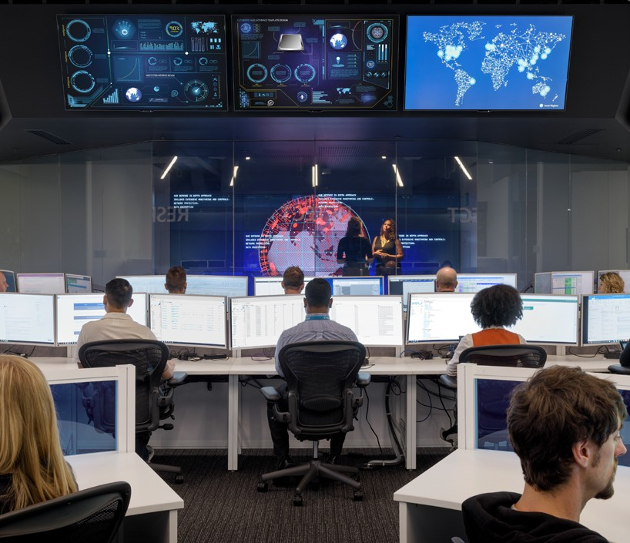

# Executive Summary

It's been a tough year in Australia with the devastating Bushfire season, damaging floods across several regions and now the onset of COVID-19. All of these can impact our community safety, health and wellbeing – and we know these events place additional load on the services provided by our Government’s Health, First Responders, Public Safety and associated Agencies, along with NGO's, NFP’s and Volunteer organisations also involved in delivering support.

In some cases, the impact is broader and places a disruptive load on our Customers, Partners, and our own Staff. Microsoft is actively working across many jurisdictions Worldwide and here in Australia to provide additional Support Services.

Some of these services are part of Business-as-Usual arrangements with our Partners and Customers, e.g. Premier Support, others are being provided through our Microsoft Humanitarian Disaster Response (MSDR) function, Microsoft Philanthropies, Non-Profit benefits etc.

We recognise there's a spectrum of priorities across Response -> Recovery -> Rebuild … and then Readiness for next incident cycle. This paper focuses on what can be done now – we're also building a Blueprint that can be used to drive continual improvement in execution through each iteration of DR/EM event lifecycle.

For further information, please contact your Microsoft Account Manager.

# Common Customer Asks & Missions

We've learnt a lot through many years of working with our Emergency/Disaster Response Teams, Partners and Customers of every shape and size – Worldwide and here in Australia.

Common Customer asks and Support Missions currently being evaluated and delivered include:

* System Resilience & BCP (availability, performance, security) of Critical Infrastructure and Business Systems impacted by much higher levels of load (Public, Partners, Public, Staff) vs BaU operations
  + www presence (migrate to Cloud)
  + Remote Access (build or scale remote access, virtual desktop services to enable Remote-work and Work-from-Home)
  + Back-end systems (provide additional scale, and/or migrate to the Cloud)
* Dashboards: for Operational staff, Leadership and Public use
* No-code / Low-code App Development (Forms for data capture, simple workflow)
  + Staff Safety Status
  + Quickly stand-up data capture and process workflow for inspection/validation scenarios at high-volume sites (e.g. Airports, Ports, Emergency Care Centres)
  + Allocation & Tracking of Assets & Staff deployed to Rapid Response activities
* Mapping, GIS & Location Services
* Natural Language Processing (NLP): Various Data Matching and correlation recommendations across structured and unstructured data
* Automating Language Translation: e.g. Inbound Case Reports -> Triage
* Digital Agents: Assist with front-line Call Centre capture load
* Registry Services: e.g. Dangerous sites & materials
* Data Matching: e.g. Fraud Detection
* Grants Management … etc

# Priority Solution Scenarios

We've collated a series of topics, support guidance and offerings to help you as we deal with current increased load on our systems.

## Business Continuity

Microsoft provides mission critical infrastructure through our globally accessible cloud services – priority areas of current focus includes:

* Business Continuity Planning (BCP) & Management
  + Microsoft’s Enterprise Business Continuity Management Program (ECBM)
  + Our Customers
    - Scaling Remote Access, via a combination of
      * Web
      * Azure Windows Virtual Desktop (WVD)
      * Azure AD Application Proxy
      * Teams
    - Operational Systems (back-end - scale, availability, security)
* Emergency & Trial Licencing
* Microsoft Teams enabled Scenarios
  + Work-from-Home: Allow staff to work from home, remain connected, work securely and stay productive
  + Remote & Distributed Field Staff: Enable staff to work in remote (away from their normal office) and in distributed work groups across multiple device options
  + Inter-Agency Collaboration: Enabling Taskforces to mobilise and securely collaborate across Agencies and in remote and distributed work locations
  + Voice: Leverage to ensure ongoing Voice services (via Internet) when PSTN landline and Mobile services are disrupted

## Communication, Collaboration and Service Delivery

Many organisations are inundated with the unexpected load on their Service/Call Centres – our guidance is to consider the following:

* **Crisis Communications:** Response Command Centre and Support Agencies
  + Inbound
    - Teams for Collaborative environments to provide response support (e.g. access to subject-matter-experts) to front-line Call Centre load
    - Digital Agents (bots) to provide an alternate (or supplement) to voice/web channels, and/or linked to Knowledge base supporting your Call Centre or Service Desk representatives during high-volume Q&A and Service Request loads
  + Inter-Agency
    - Agencies directly involved in providing services to address Co-ordination and
  + Outbound (for Agency staff)
    - Teams for Agency-wide Meetings and Taskforce Workgroup collaboration
    - Organisational Broadcast Events (Streamed Live and Recorded for replay)
    - Yammer for Agency-wide discussion
* **Distributed Communication and Application Delivery for Distributed Service Delivery:** Scenarios where there are distance and geographic separation between Domain Specialists (who may be centralised in a city/urban location) and Customers (e.g. Patients) or Field Workers (who may be in remote/rural locations) e.g. TeleHealth etc.

Many Agencies are involved either directly or in a third-party support function behind front-line Support and Service Delivery Agencies. These Agencies can leverage scenarios above to either provide ongoing support services to other Agencies, or to allow their staff to work remotely (e.g. from Home).

Microsoft is preparing a paper specifically addressing Remote Worker scenarios for our Australian Public Sector Customers << target release w/c 9/3/2020 >>

# Resources & Guidance

## Licensing Trials & Offers

* **Microsoft 365 Customer Trials Sales Team Support – Office 365 E1/G1 Trail:** <https://transform.microsoft.com/customer-trials?tab=o365e1trial>
* << internal link – to be removed for external release – Microsoft Teams COVID-19 Response: <https://microsoft.sharepoint.com/teams/MicrosoftTeamsCOVID-19Response> >>
* **Working remotely during challenging times:** <https://www.microsoft.com/en-us/microsoft-365/blog/2020/03/02/working-remotely-during-challenging-times/>
* **Our commitment to customers during COVID-19:** <https://www.microsoft.com/en-us/microsoft-365/blog/2020/03/05/our-commitment-to-customers-during-covid-19/>

## Cloud Services Compliance & Guidance

* **Enterprise Business Continuity Management (EBCM) Program:** <extract> Pandemic events can have significant impact to any global organisation. Through effective planning and design, Microsoft has worked to reduce the potential impact this has on our customers, partners and Microsoft employees. As a core part of operating a global cloud service, Microsoft plans for and regularly validates a global business continuity plan, of which pandemic response is a scenario which we have considered and have appropriate procedures in place to handle.
* **Microsoft Trust Centre:** The Microsoft Service Trust Portal contains IRAP assessment reports, various global certification reports, and white papers to assist customers in completing their own security assessments and accreditations.
  + <https://aka.ms/stp> (search for ECBM), refer to:
    - Microsoft Cloud – Enterprise Business Continuity Management (ECBM) Program
    - Microsoft Cloud – ECBM – Business Continuity and Disaster Recovery Plan Validation Report – FY20/Q2
  + <https://servicetrust.microsoft.com/ViewPage/AustraliaV3>
    - 2019 Microsoft Azure IRAP Assessment Report
    - 2019 Microsoft Office 365 IRAP Assessment
* **Customer Readiness**
  + **Microsoft Azure Services**
    - **Microsoft Azure Portal (Help & Support):** <https://portal.azure.com>
  + **Microsoft 365 Services:** <https://docs.microsoft.com/en-us/microsoft-365/enterprise/ebcm-understanding-ebcm-with-cloud-services?view=o365-worldwide>
* **Microsoft Australia 'Rapid deployment of Remote Worker scenarios with Microsoft 365’:** << target release 9/3/2020 … draft of this is available & broadly relevant, but does have some Federal/VSA specifics to be adjust for State Govt audience. >>
* **Microsoft 365 preparedness for COVID-19 (Coronavirus) and guidance regarding best practices for Microsoft Teams:** Office 365 Admin Centre -> Message Centre: Search for ‘MC205458’
* **Microsoft IT Showcase:** <https://www.microsoft.com/en-us/ITShowcase>

ToDo: Incorporate Accessibility topics to emphasise during Emergency Response, distributed workforce, WFH scenarios etc (BJ -> DavidM, AaronD)

## Solution Patterns & Templates, MVP's, OSS

* **Azure Windows Virtual Desktop:** Enterprise Desktop in the Cloud
  + **Adoption:** Getting started with building a pool of virtual machines, providing connectivity, integrated security and management. <https://docs.microsoft.com/en-us/azure/virtual-desktop/>
  + Guidance on Pre-requisites, Project Plan, Deployment Options, Design Patterns, Host Sizing << target release w/c 9/3/2020 >>
* **Power Platform:** Crisis Communication & Worker Status
  + **Template:** Staff can register their Safety & Work Status (e.g. WFH), Admins can push news & updates, RSS feeds for information updates (e.g. WHO, CDC etc) – Web, Teams, or Mobile accessible. <https://powerapps.microsoft.com/en-us/blog/crisis-communication-a-power-platform-template/>
  + **Licensing:** Temporary access to a premium feature, Power Apps Push Notifications, so you won’t need any premium licenses to use Power Apps to push information to users. We have reclassified Push Notifications as a standard connector for the duration of the COVID-19 crisis. <https://www.linkedin.com/posts/peterschmidtperth_crisis-communication-a-power-platform-template-activity-6641207646269607936-Db8t>
* **Microsoft Teams:** Collaboration, Productivity, Information Sharing & Enterprise Voice
  + **Remote Workers:** There has been a new set of resources developed focused specifically on rapid adoption of Teams to support remote workers (WFH). This guidance targets the end-user and provides resources for IT supporting these Remote Workers. <https://docs.microsoft.com/en-us/microsoftteams/support-remote-work-with-teams>
  + **Broadcast Communications:** Broadcast video and meeting content to large online audiences across your organisation. Microsoft Teams Live Events bring live video streaming (Azure Media Services, Stream) to a new level, encouraging connection throughout the entire engagement lifecycle with attendees before, during, and after live events. You can create a live event wherever your audience, team, or community resides, using Microsoft Stream, Teams, or Yammer. <https://docs.microsoft.com/en-us/microsoftteams/teams-live-events/what-are-teams-live-events>
  + **App Templates (e.g. Company Communicator):** Enables corporate teams to create and send messages intended for multiple teams or large number of employees over chat allowing organization to reach employees right where they collaborate. Utilize this Template for multiple scenarios such as new initiative announcements, employee onboarding, modern learning and development or organization-wide broadcasts. The App provides an easy interface for designated users to create, preview, collaborate and send messages. It provides a foundation to build custom targeted communication capabilities such as custom telemetry on how many users acknowledged or interacted with a message. <https://docs.microsoft.com/en-us/microsoftteams/platform/samples/app-templates>
  + **Adoption:** Guidance to assist with rapid adoption of Microsoft teams. Help you understand the types of teams and channels, explore usage scenarios relevant to your agency, define a enablement strategy and required change management. <https://docs.microsoft.com/en-us/microsoftteams/adopt-microsoft-teams-landing-page>
  + **Resources Hub:** A set of email templates, posters, usage guides, and surveys for user feedback. <https://www.microsoft.com/en-au/fasttrack/resources>
  + **Licensing**: We are making a 6-month Office 365 E1/G1 trial, including Microsoft Teams, available for customers who are affected by COVID-19. This is available to all Microsoft managed customers with no limit to the number of trial licenses that can be requested. <https://www.microsoft.com/en-us/microsoft-365/blog/2020/03/05/our-commitment-to-customers-during-covid-19/>
* **Data and AI Services**
  + **Conversational AI for Healthcare:** The Microsoft Healthcare Bot service empowers healthcare organizations to build and deploy an AI-powered, compliant, conversational healthcare experience at scale. The service combines built-in medical intelligence with natural language capabilities, extensibility tools and compliance constructs, allowing healthcare organizations such as Providers, Payers, Pharma, HMOs, Telehealth to give people access to trusted and relevant healthcare services and information. The Healthcare bot can be customised to suit Emergency Response and Government Service Delivery Scenarios.
    - <https://www.microsoft.com/en-us/research/project/health-bot/>
    - Plans & Pricing: <https://azuremarketplace.microsoft.com/en-us/marketplace/apps/microsoft-hcb.microsofthealthcarebot?tab=PlansAndPrice>
  + **Other NLP, Language Translation, Data Matching …** ??

## Implementation Programs & Services

* **Microsoft Support Services (ServicesHub):** <https://serviceshub.microsoft.com/>
* **Microsoft FastTrack (Azure, Office 365, Microsoft 365, Dynamics 365):** <https://www.microsoft.com/en-us/fasttrack>
* **Microsoft Services Disaster Response (MSDR):** Contact your Account Team
* **Microsoft Philanthropies:** <https://www.microsoft.com/en-us/corporate-responsibility/philanthropies/humanitarian-action>
* **Microsoft Non-Profits:** <https://www.microsoft.com/en-us/nonprofits/microsoft-365?&OCID=AID2000043_SEM_XkDncQAAAH8JTV4y:20200305045440:s&msclkid=e3c928b053af14655b3e76d0d5aa8af0&ef_id=XkDncQAAAH8JTV4y:20200305045440:s>
* **Microsoft's donations & contributions through Benevity:** <https://causes.benevity.org/>